Network Defense with Suricata – Detailed Report

1. Objective
This project demonstrates the implementation of network defense using Suricata. The objective was to configure Suricata as an Intrusion Detection and Prevention System (IDS/IPS), create custom rules to block malicious traffic, and map detected activity to MITRE ATT&CK techniques.

2. Lab Setup
Two virtual machines were used:
- Defender Machine: Kali Linux running Suricata
- Attacker/Test Machine: Separate VM used to generate traffic
Both machines were connected using a Host-Only network with IP range 192.168.56.0/24.

3. Installation and Configuration
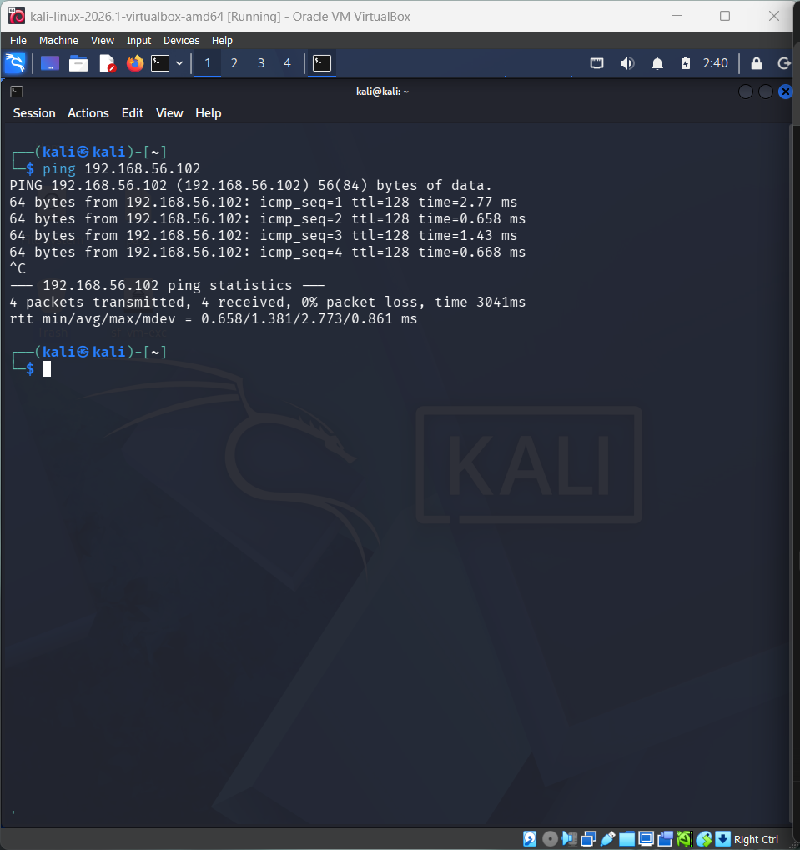
Suricata was installed using the package manager. The configuration file (suricata.yaml) was modified to:
- Set HOME_NET to 192.168.56.0/24
- Configure rule-files to load local.rules
- Ensure correct rule path was used
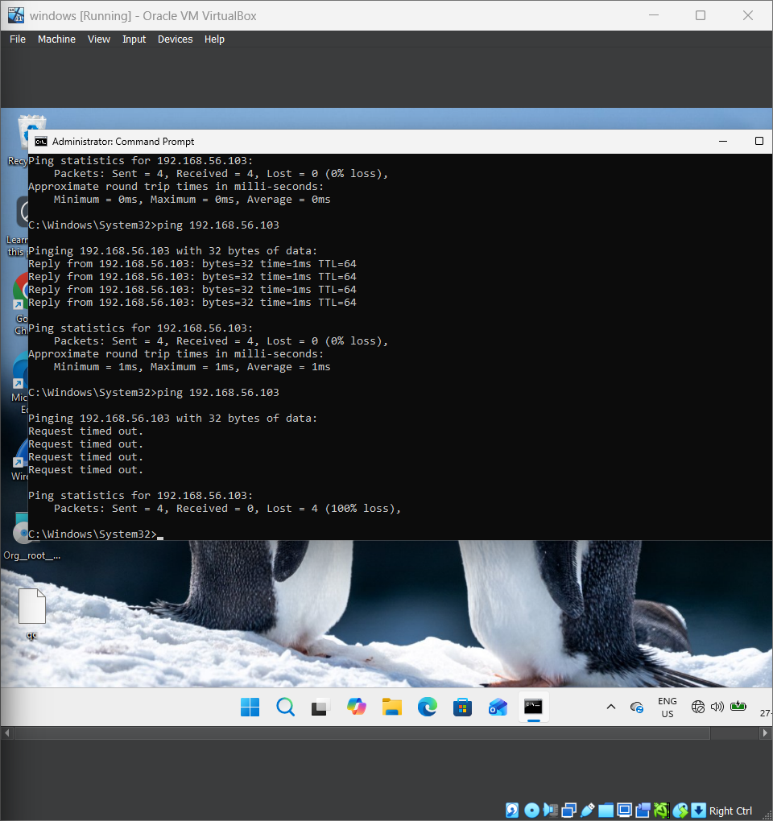

4. Rule Creation
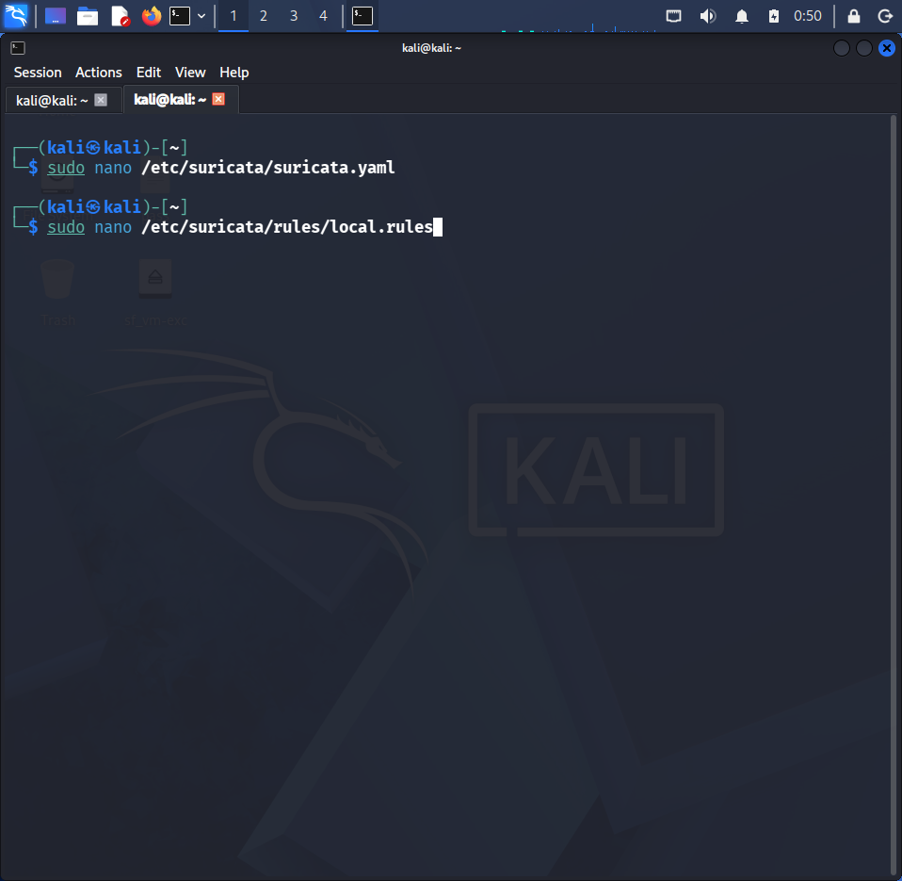
A custom rule was created to block traffic from a specific IP address:
drop ip 192.168.56.102 any -> any any (msg:"Block Malicious IP"; sid:1000001; rev:1;)
This rule instructs Suricata to drop all traffic originating from the specified IP.

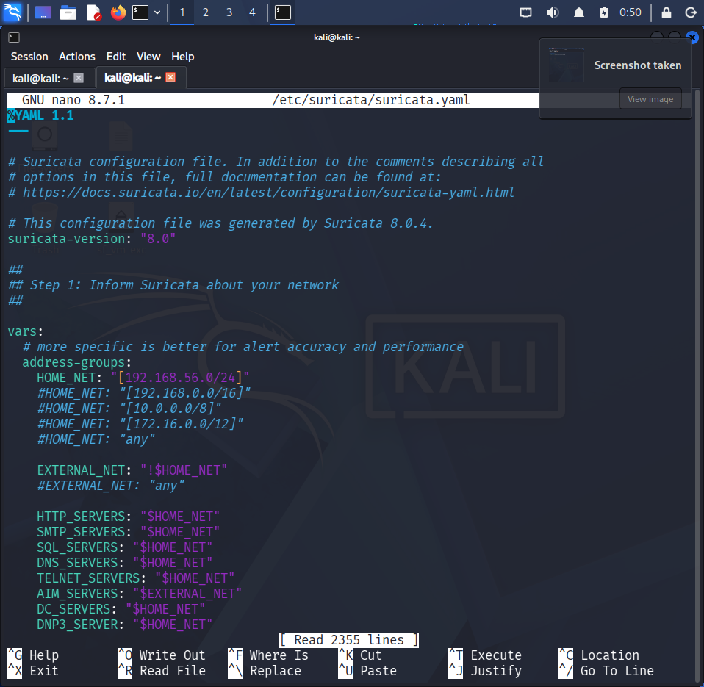

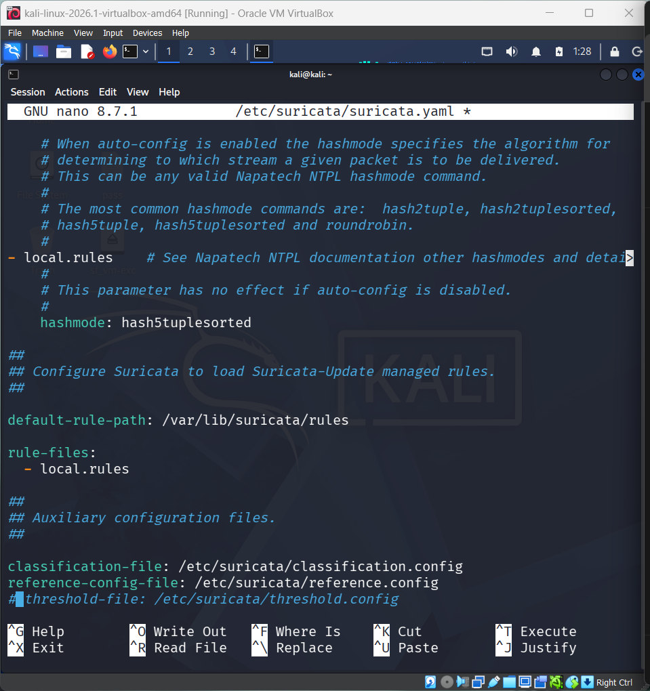

5. Enabling IPS Mode
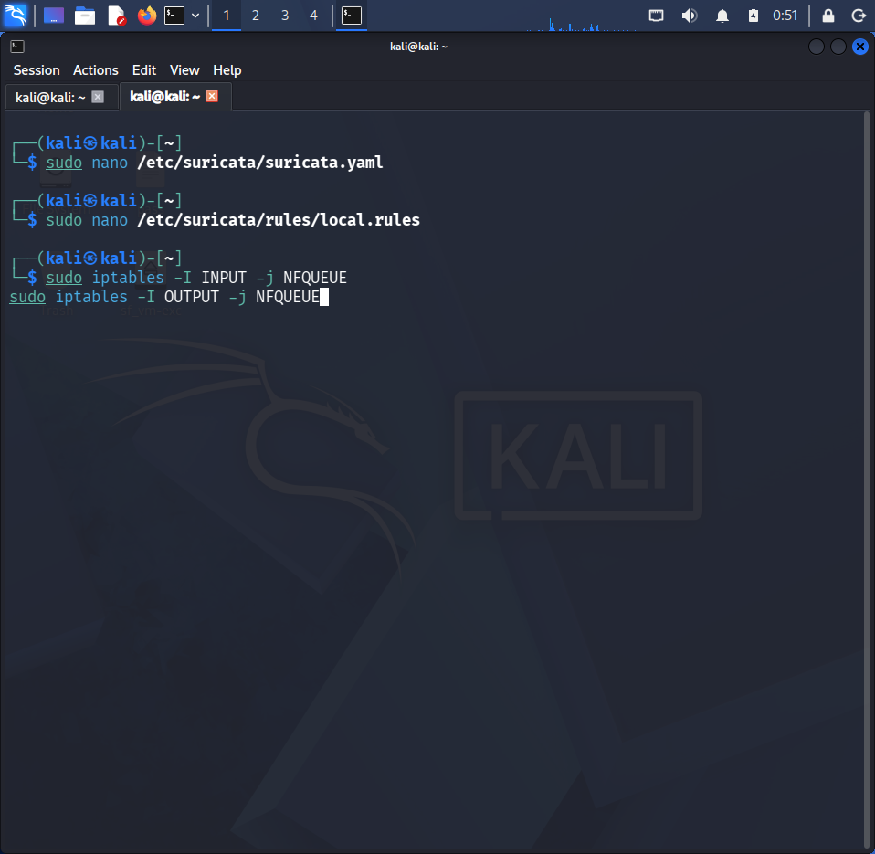
Suricata was run in inline (NFQUEUE) mode to enable packet dropping. Iptables rules were configured to send traffic to Suricata for inspection.

6. Testing
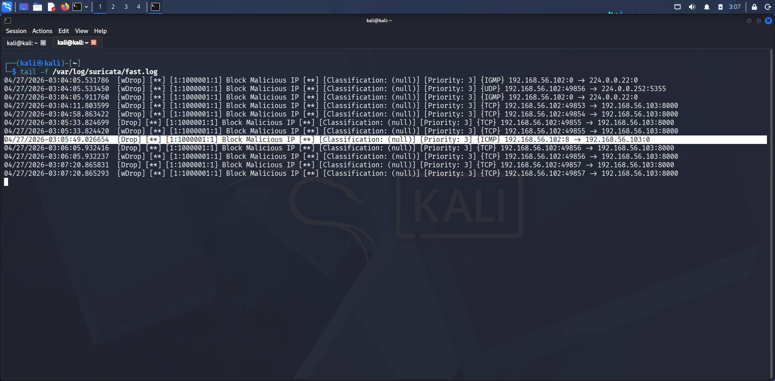

Testing was performed by sending ICMP (ping) requests from the attacker machine to the defender machine. Once the rule was active, the traffic was successfully blocked, demonstrating the effectiveness of the IPS setup.

7. Log Analysis
Alerts generated by Suricata were observed in log files such as fast.log and eve.json. These logs confirmed that the malicious traffic was detected and dropped.

8. MITRE ATT&CK Mapping
Alert | Tactic | Technique | Description
Block Malicious IP | Command and Control | T1071 | Network communication used by attackers
Blocked Traffic | Defense Evasion | T1562 | Attempt to bypass or interfere with defenses
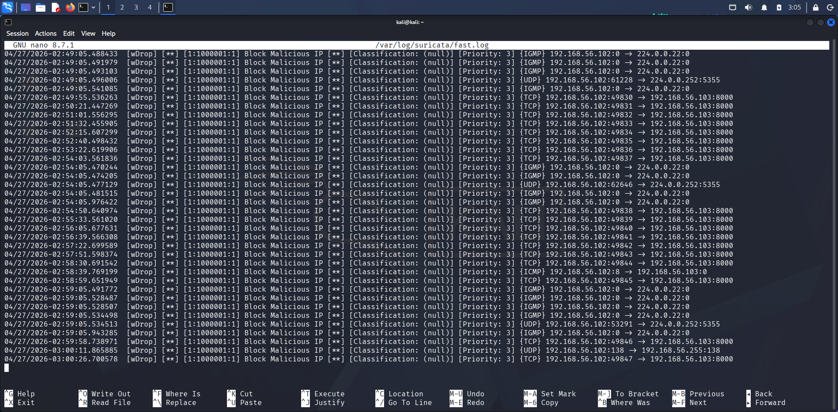  Suspicious Traffic | Initial Access | T1190 | External access attempts to system


9. Conclusion

The project successfully demonstrated how Suricata can be used to detect and block malicious network traffic. The integration of detection results with MITRE ATT&CK provides a structured understanding of attacker behavior. No real compromise was observed, but the system effectively prevented unauthorized communication.

